Exercise 4: MMAS and MMAS* Analysis

1. Introduction
This report compares two ACO algorithms: MMAS and MMAS* on seven benchmark functions. The key difference: MMAS accepts equal fitness solutions (f(x) ≥ f(x*)) while MMAS* requires strict improvements (f(x) > f(x*)). We tested three evaporation rates: ρ ∈ {1, 1/√n, 1/n} where n=100, running each configuration 10 times for 100,000 evaluations. Results were compared against Random Search, RLS, and (1+1) EA from Exercise 2.

2. Results by Function

2.1 F1 - OneMax
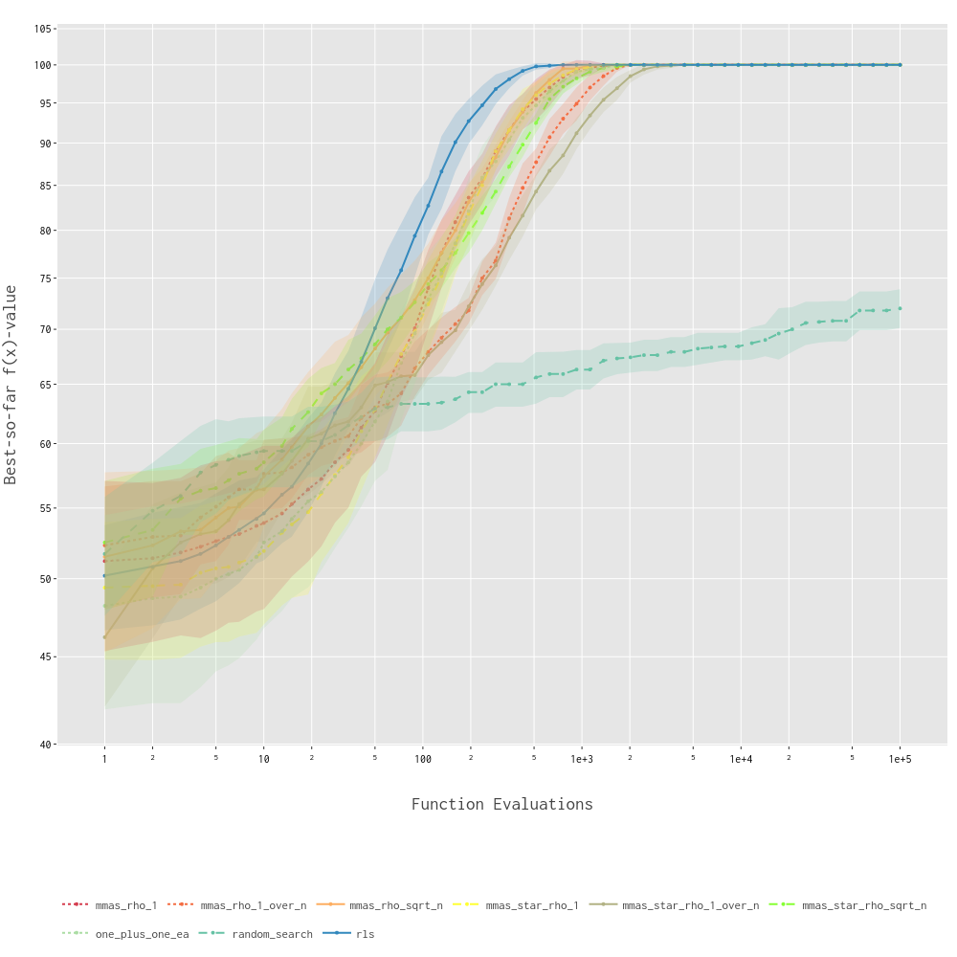
RLS dominated, reaching optimum around 500 evaluations. Among ACO variants, ρ=1/√n performed best but remained slower (~2,000-3,000 evaluations). Low evaporation (ρ=1/n) was extremely slow, only catching up around 50,000 evaluations. Random Search plateaued at ~72/100. MMAS and MMAS* showed identical performance, as expected for unimodal functions.

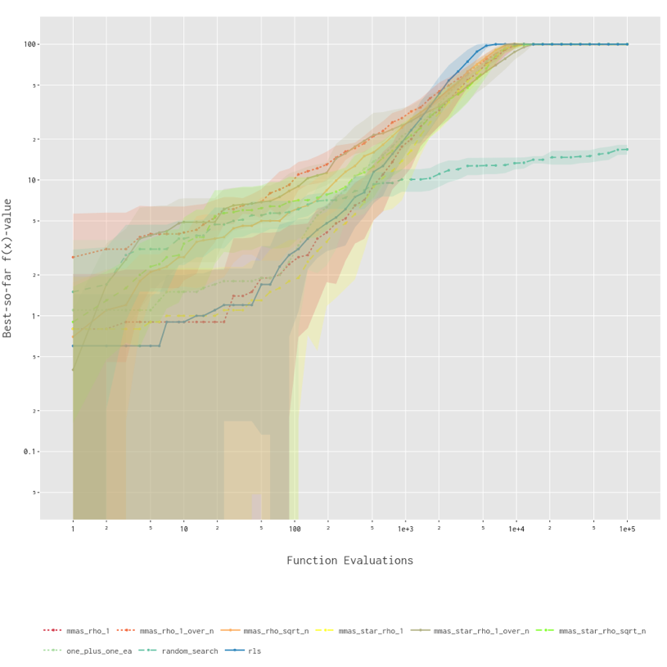
2.2 F2 - LeadingOnes
RLS excelled on this sequential function (~10,000 evaluations to optimum). ACO algorithms struggled more than on OneMax due to prefix dependencies. Best ACO (ρ=1/√n) required 5,000-8,000 evaluations. Random Search performed poorly (~17/100). Again, no difference between MMAS and MMAS*.

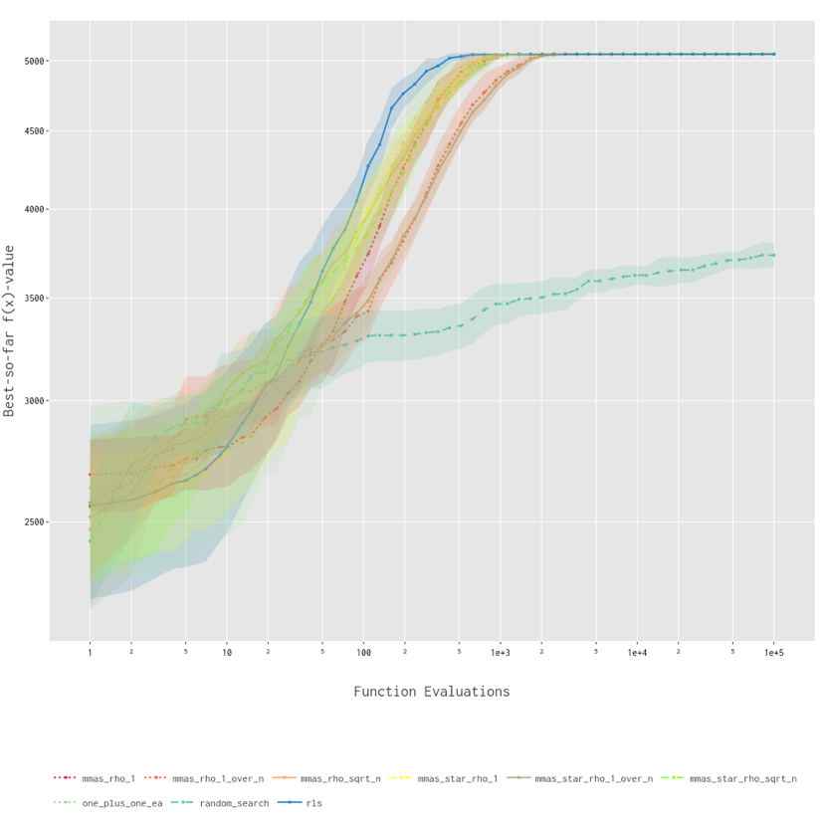
2.3 F3 - Linear
Similar pattern to OneMax. RLS fastest, followed by (1+1) EA, then ACO with ρ=1/√n. Random Search achieved ~3,700/5,050. Higher variance visible for ACO algorithms. MMAS and MMAS* remained indistinguishable.

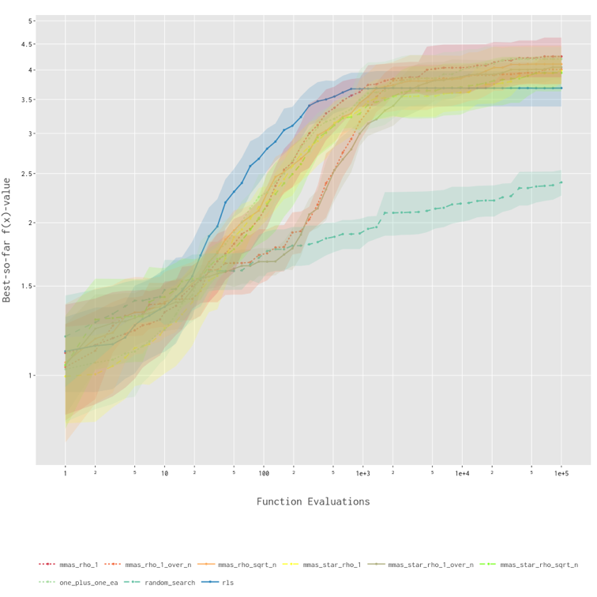
2.4 F18 - LABS
First function where ACO became competitive. MMAS with ρ=1 matched RLS performance (~3.7-3.8 fitness). Both ρ=1 and ρ=1/√n worked well, unlike unimodal functions. Wide confidence bands indicate problem difficulty. (1+1) EA performed worse than some ACO variants—first clear ACO advantage.

2.5 F23 – Nqueens
RLS showed sharp improvement around 300 evaluations, plateauing at ~8-9 queens. All other algorithms clustered together at similar performance. Critically, this plateau function showed no observable difference between MMAS and MMAS*, contradicting theoretical predictions that MMAS should outperform MMAS* on plateaus.

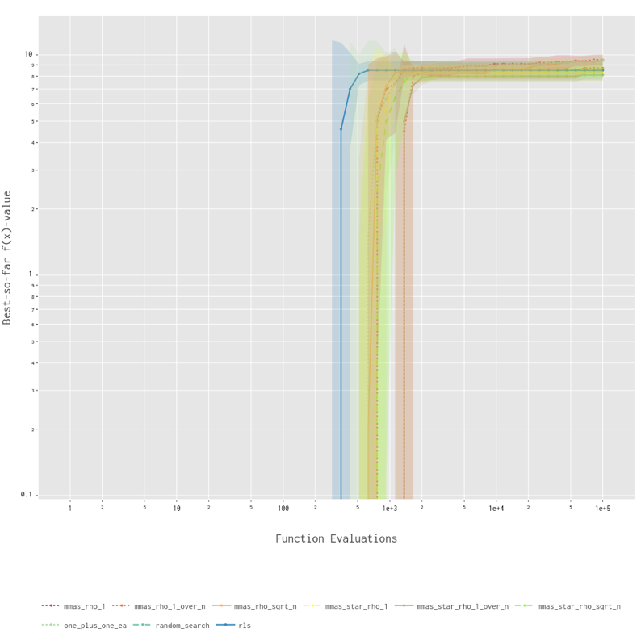

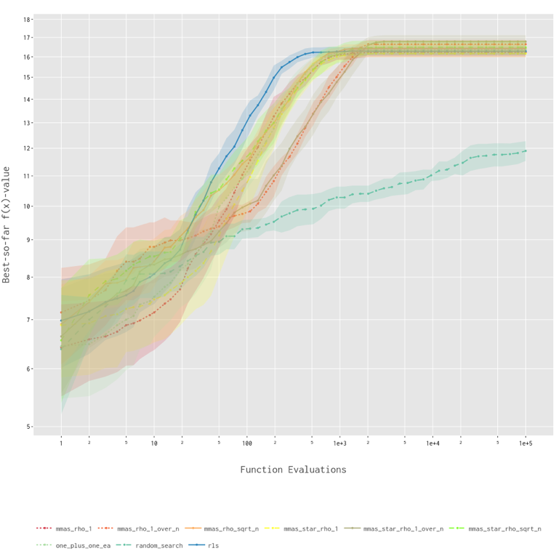
2.6 F24 - ConcatenatedTrap
RLS best (~16.5), MMAS ρ=1/√n close second. Large variance across runs indicates deceptive landscape difficulty. Random Search relatively better (~12) since it's not misled by deceptive gradient. No MMAS vs MMAS* difference observed.

2.7 F25 – NKLandscapes
ACO algorithms clearly outperformed evolutionary baselines. MMAS* ρ=1/√n achieved best results (~-0.40), with MMAS performing identically. (1+1) EA fell to middle of pack. Despite being a plateau function with epistasis, MMAS and MMAS* showed no performance difference*.

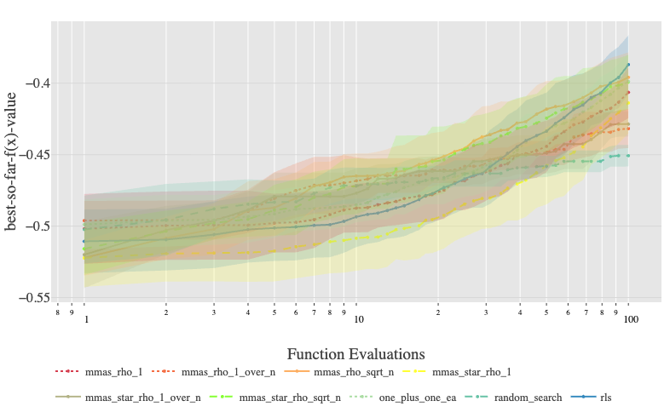

3. Analysis

3.1 Effect of ρ Parameter
ρ = 1/√n: Won or tied on all 7 functions. Optimal balance between adaptation and persistence. Recommended default.
ρ = 1: Competitive on complex landscapes (F18, F24). Behaves like (1+1) EA when pheromones hit boundaries quickly.
ρ = 1/n: Consistently worst. Too slow within 100k budget. Should be avoided.

3.2 MMAS vs MMAS*
Expected: MMAS should outperform MMAS* on plateaus (F23, F25) by accepting equal-fitness solutions.
Observed: No measurable difference on any function, including plateaus. Curves overlay exactly for matching ρ values.
Possible explanations:
- 100k evaluation budget may be insufficient for the differences to emerge.
- Benchmark plateaus more complex than the theoretical examples (NEEDLE).
- Pheromone update mechanism dominates over the selection mechanism.
- Theory considers asymptotic behaviour, not finite-time performance.

3.3 ACO vs Evolutionary Algorithms
RLS/EA win: Unimodal functions (F1, F2, F3) and constrained problems (F23) ACO competitive/wins: Complex landscapes (F18, F24, F25)
Pattern: ACO's pheromone memory helps on rugged multi-modal landscapes but adds unnecessary overhead on smooth functions.

4. Conclusions
Key findings:
- ρ = 1/√n is robust across all problem types
- MMAS vs MMAS* distinction has negligible practical impact
- Parameter choice (ρ) matters far more than selection mechanism
- ACO excels on complex landscapes, struggles on simple unimodal functions
Practical recommendations:
- Default to ρ = 1/√n
- Use RLS for known unimodal functions
- Either MMAS or MMAS* acceptable—no meaningful difference observed
- Avoid ρ = 1/n
The surprising lack of MMAS/MMAS* differences suggest theoretical worst-case analyses may not capture typical behaviour on practical benchmarks. Parameter tuning (ρ) proves more important than algorithmic details (selection mechanism) for practitioners.

